FLOW CHART

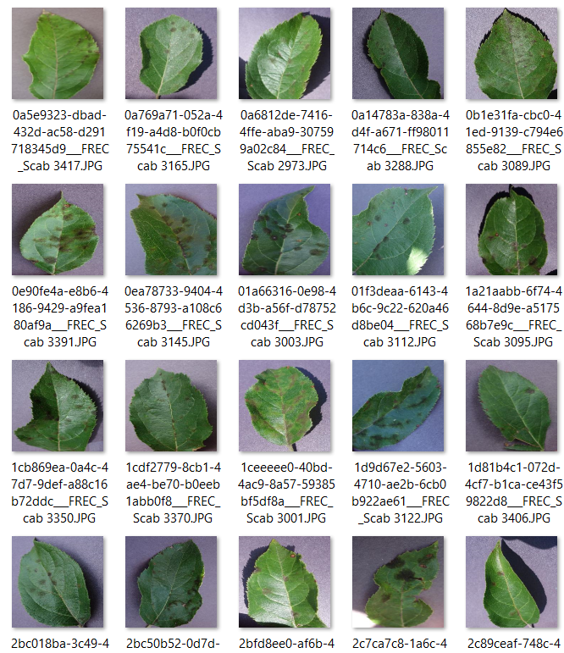

**PRE-PROCESSING**

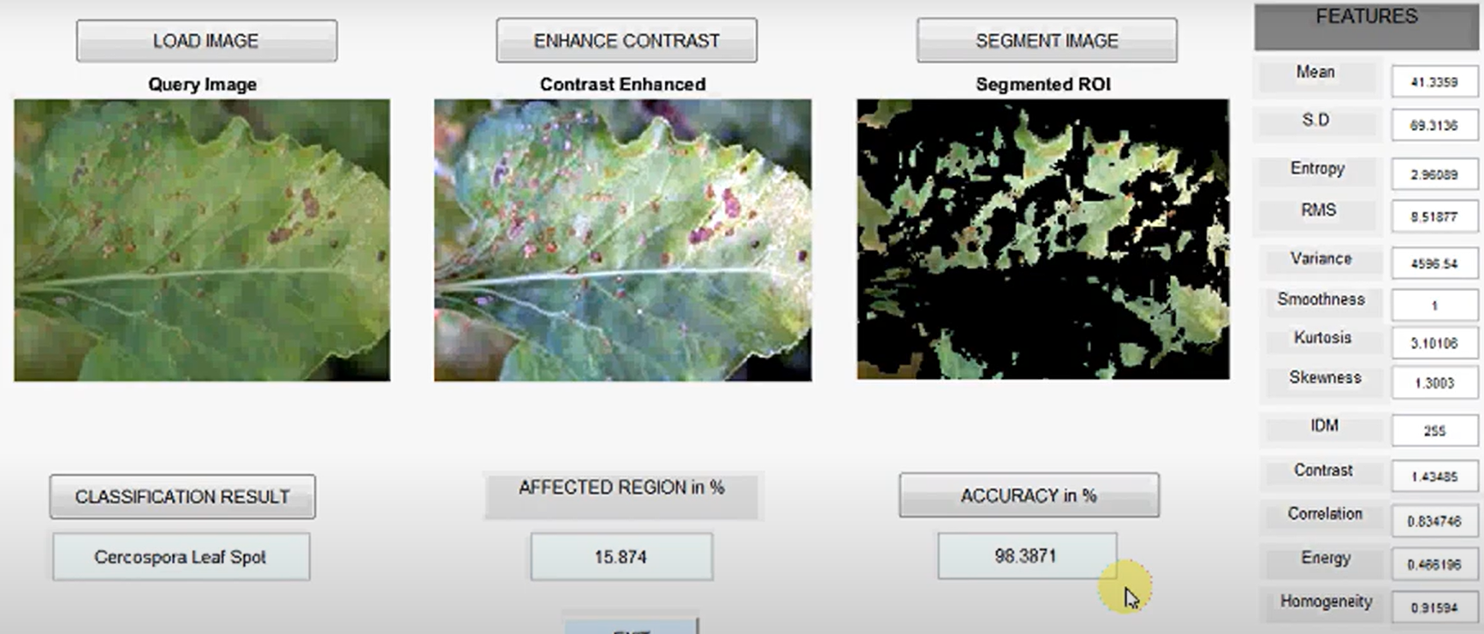

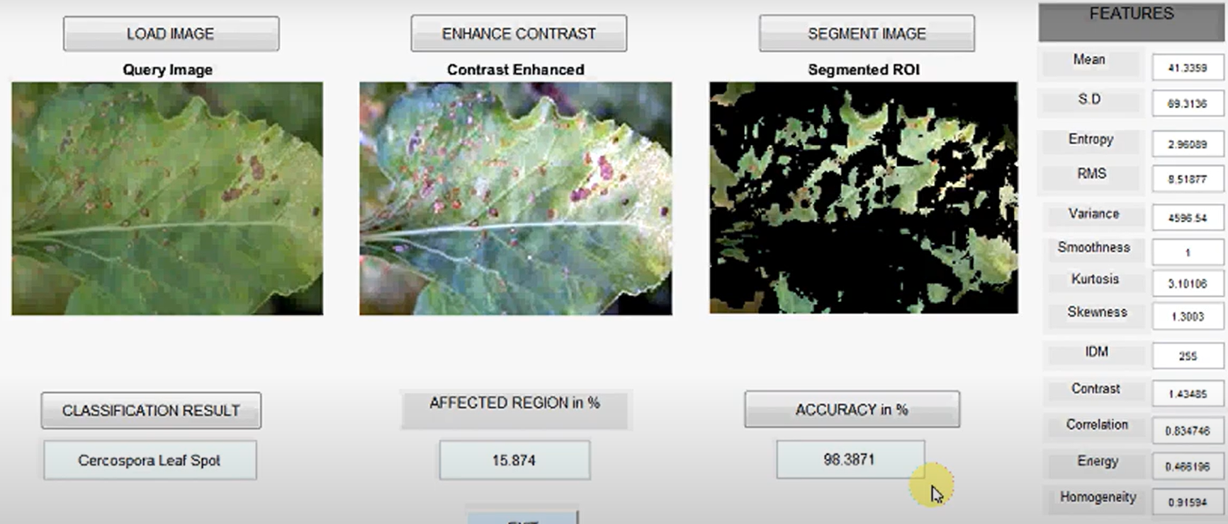

**Support vector machine**

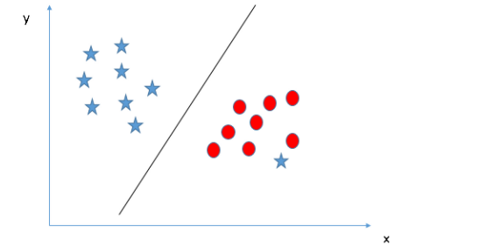

**CLASSIFICATION WITH SVM MODEL**

**prototype**

**CNN MODEL**

**MODEL**

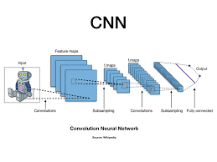

Image pre-processing is done by segmenting the **images**

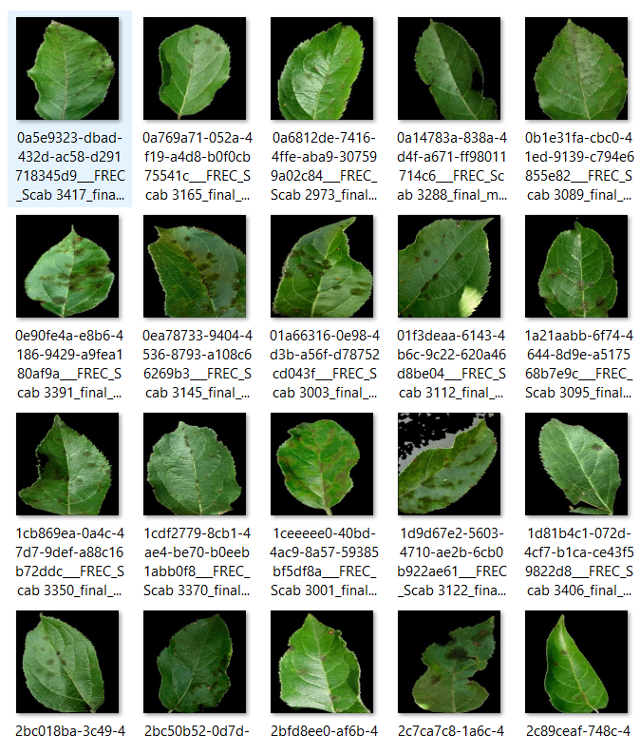

**Dataset**